**DELHI TECHNOLOGICAL UNIVERSITY**

**Utilization of Electrical Energy Report**

**Thermo Electric Refrigeration**

**Under supervision of: Dr. R. Saha**



**Submitted by:**

**PRAJJWAL CHITTORI (2K18/CO/249)**

**(Dept. of Computer Science and Engineering)**

# ABSTRACT

* 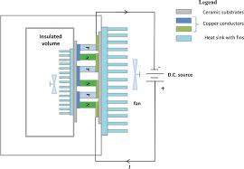 The impact of on-going progress in Science and Technology has created a variety of systems that can be used in producing of refrigeration effect with the use of Thermoelectric Module and Photovoltaic Module for generation of energy which we further use for cooling and heating effect. The most important utilization of this portable cooler is for the preservation of insulin in extreme conditions A Thermoelectric module (TEM) is used instead of compressor so that it become portable, as it is based on the principles of Peltier effect. The use of Peltier effect is to create a heating side and a cooling side and also to maintain effectiveness
* Thermoelectric cooler (TEC) is a solid state heat pump which uses the components are available commercially. The thermoelectric refrigerator does not produce chlorofluorocarbon (CFC). It is pollutant free-contains no liquids or gases, portable, compact,

creates no vibration or noise because of the difference in the mechanics of the system. It is a prototype and its semiconductor materials, by Peltier effect, to provide instantaneous cooling or heating. It has the advantage of having no moving parts and thus maintenance free.

Therefore, the need for thermoelectric refrigeration in developing countries is very high where long life and low maintenance are needed. The objectives of this study is to develop a working thermoelectric refrigerator to cool a volume of 40 L that utilizes the Peltier effect to cool and maintain a selected temperature range of 5 0C to 25 0C. The design requirements are to cool this volume to temperature within a short time and provide retention of at least next half an hour. The design and fabrication of thermoelectric refrigerator for required applications are presented.

A thermoelectric module thus uses a pair of fixed junctions into which electrical energy is applied causing one junction to become cold while the other becomes hot. Because thermoelectric cooling is a form of solid-state refrigeration, it has the advantage of being compact and long lasting.

**Introduction to Thermo Electric Refrigeration**

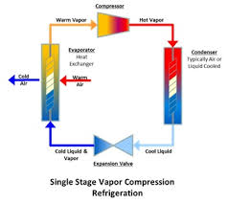When a closed circuit of two dissimilar metals and two junctions is formed, a current will flow between the junctions or the circuit. This phenomenon is known as the Seebeck effect. Jean.C.Peltier, a French watchmaker and an amateur scientist discovered a reverse effect of the Seebeck. He discovered that using joined dissimilar metals heat pump can be made.

Thermoelectric cooling uses the Pettier

effect to create a heat flux between the junctions of two different types of materials. A Peltier cooler, heater or thermoelectric heat pump is a solid-state active heat pump which transfers heat from one side of the device to the other, with consumption of electrical energy, depending on the direction of the current.

Such an instrument is also called a Peltier device, Peltier heat pump, solid state refrigerator, or thermoelectric cooler (TEC). It can be used either for heating or for cooling, although in practice the main application is cooling. It can also be used as a temperature controller that either heats or cools.

**Methods of refrigeration**

* **Cyclic refrigeration** 
  + 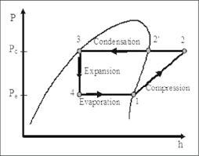**Vapor-Compression cycle**
  + 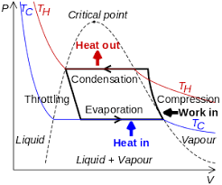**Vapor- absorption cycle**
* **Non-cyclic refrigeration** 
  + 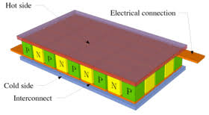**Thermoelectric refrigeration**
  + 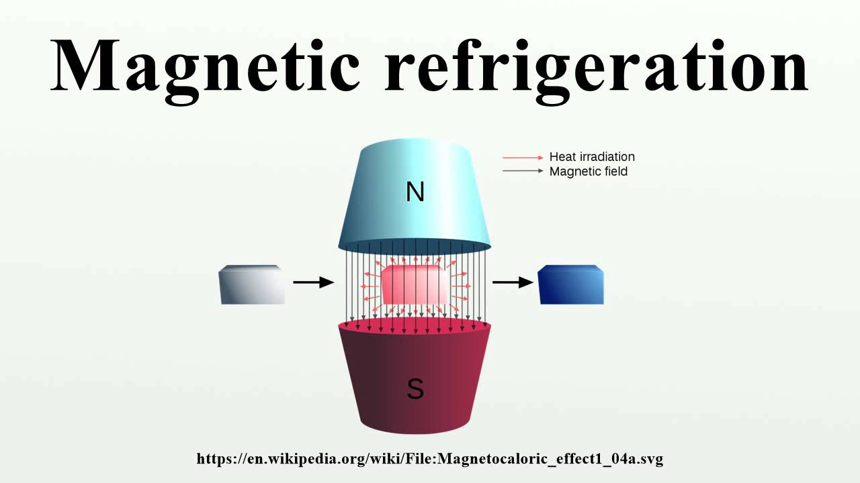**Magnetic refrigeration**

**Thermoelectric Refrigeration**

* 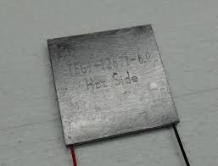[**Thermoelectric cooling**](https://en.wikipedia.org/wiki/Thermoelectric_cooling) **uses the** [**Peltier effect**](https://en.wikipedia.org/wiki/Peltier_effect) **to create a heat** [**flux**](https://en.wikipedia.org/wiki/Flux) **between the junction of two different types of materials. This effect is commonly used in camping and portable coolers and for cooling electronic components and small instruments.**
* 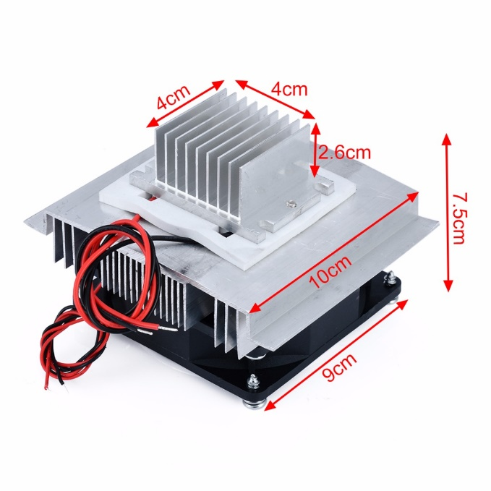**The two dissimilar conductors are doped in a ceramic wafer this ceramic component is pielter device for which produces the cooling effect which we use it as component for refrigeration.**

**Principles of Working**

* **PELTIER EFFECT**
* 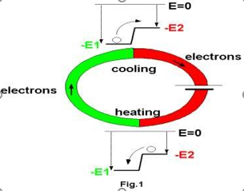**The thermoelectric refrigerator works on the PELTIER effect that The Peltier–Seebeck effect, or thermoelectric effect, is the direct conversion of thermal differentials to electric voltage and vice versa. Related effects are the Thomson effect and Joule heating. The Peltier– Seebeck and Thomson effects are reversible (in fact, the Peltier and Seebeck effects are reversals of one another); Joule heating cannot be reversible under the laws of thermodynamics.**

**Description of Parts**

* **Thermo electric module**

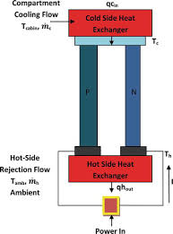Thermoelectric modules (Peltier modules) are solid-state heat pumps that operate on the Peltier effect. Heat pump is a thermodynamic system, which transfers heat from low temperature body and gives out same to high temperature body.

**Heat sink**

A heat sink is a passive [heat exchanger](https://en.wikipedia.org/wiki/Heat_exchanger) that transfers the heat generated by an electronic or a mechanical device into a coolant fluid in motion. Then-transferred heat leaves the device with the fluid in motion, therefore allowing the regulation of the device temperature at physically feasible levels.

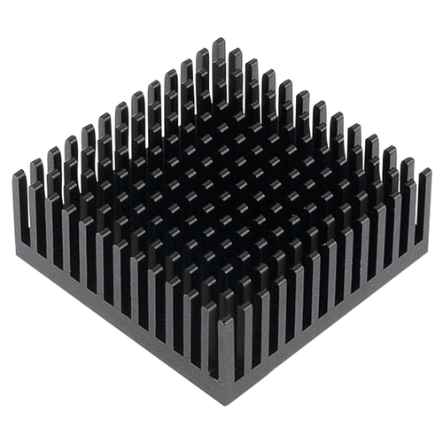

Heat sink fan

* 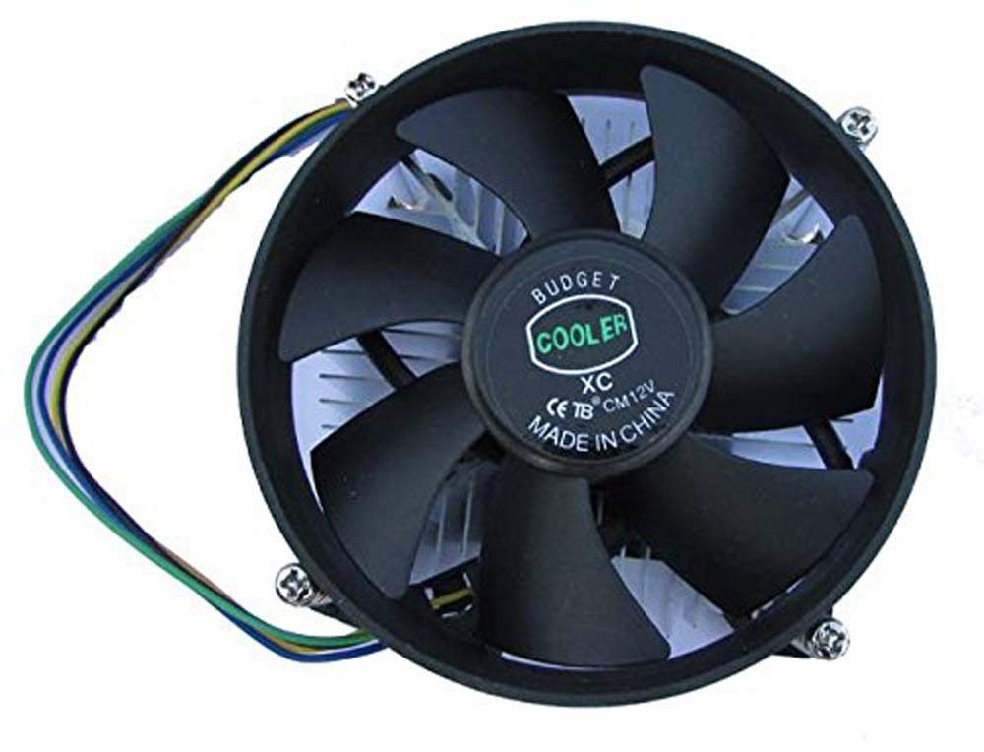Sometimes the heat sink itself becomes hot during the heat transfer to overcome this problem a device called heat sink fan is used for the removal of induced heat in the fins of the heat sink..So these fans are attached over the fins of the heat sink and it cools down the heat produced in the heat sink .

**Temperature indicator**

* 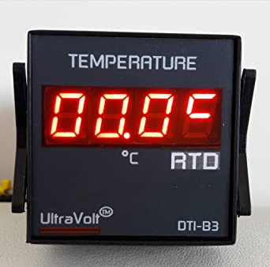The temperature indicator is device that is used to know about the temperature inside the chamber of refrigerator. It has a probe which is inserted inside the chamber of refrigerator and the probe senses the temperature inside and gives the temperature data to the output display.

**Battery**

* Battery is used send current to the refrigerator it is of 6 volts and 7.5 amperes and is of rechargeable type.

**Thermal casing**

* 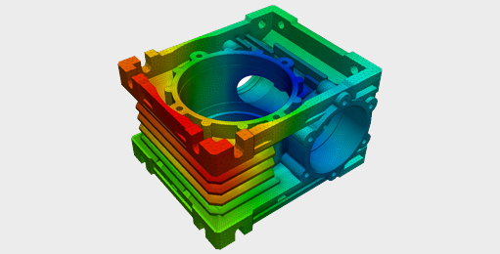Thermal casing is made of thermo coal and is used for keeping cool inside and to store the storage beverages and food stuffing’s in the refrigerator.

**Specifications of refrigerator**

* **Module**
* **Model number: TEC1-12706**
* **Voltage : 12V**
* **U max (V) : 15.4V**
* **Imax (A) : 6A**
* **Q Max (W) : 92W**
* **Internal resistance: 1.98 Ohm +/- 10%**
* **Dimensions : 40mm x 40mm x 3.6mm**
* **Power Cord : 350mm**
* **HS Code: 854150**
* **Type: Cooling Cells**
* **Usage: Refrigerator/Warmer**
* **Dimension: 40*40*3.8mm**

**Power calculations**

* **Electrical power is used to run the refrigerator and the details are mentioned below**
* **Source: 12volts DC battery**
* **Module: 12 volts**
* **Fans: 7 amps**
* **Temperature indicator: 12 volts**
* **No of Phases: 1 phase**
* **Minimum power required is 12 volts and a maximum of 56 volts and it is supplied by the dc source (battery)**
* **Electrical Data**
* **Power source: 12volts dc battery**
* **Ratted supply: 12volts 7.5 amps**
* **Fan speed**
* **Minimum speed: 1000RPM**
* **Moderate speed: 2000RPM**
* **Maximum speed: 3000RPM**

**Comparison with normal refrigerator**

|  |  |  |  |
| --- | --- | --- | --- |
| **S no** | **Criteria** | **Thermo electric**  **refrigerator** | **Normal**  **refrigerator** |
| **1** | **Cooling method** | **Non Cyclic**  **refrigeration** | **Vapour**  **compression**  **cycle** |
| **2** | **Components** | **Thermo electric**  **module** | **Condenser, Compressor, Evaporators** |
| **3** | **Main advantage** | **Portable** | **Not portable** |
| **4** | **Power**  **Consumption** | **12-56 volts** | **220volts** |
| **5** | **COP** | **Comparatively**  **less** | **High COP** |
| **6** | **Uses** | **Melting of**  **chocolates**  **Insulin**  **preservation etc** | **Ice**  **Cold water etc.** |

**Advantages**

* **These are environment friendly. (No C.F.C)**
* **These are light in weight.**
* **Give fast temperature response.**
* **It is portable, small in size.**
* **Can be used during travelling.**
* **Can be used at military base.**
* **Have no vibrations.**
* **Creates no noise.**

**Applications**

* **For preservation of insulin and other drugs.**
* **For preservation of food stuffs.**
* **For cold water.**
* **For beverages**

**Conclusion**

* The coefficient of performance of this refrigerator is much smaller than that of a conventional compressor-type refrigerator when the required cooling capacity is high, whereas the coefficient of performance of the conventional unit falls off rapidly as the cooling capacity is decreased and that of thermo electric unit remains constant. Thus a conventional refrigerator is preferred when the required cooling capacity is high and a thermoelectric refrigerator should be chosen when a low cooling capacity is needed. The cold side of the thermoelectric module was utilized for refrigeration purposes whereas the rejected heat from the hot side of the module was eliminated using heat sinks and fans
* As the cooling units are of small size, silent, contains no liquids or gases, have no moving parts and have a long life. It is very simple to control the rate of cooling by adjustment of the current, the response to changes in the supply is very rapid, while reversal of the direction of the current transforms a cooling unit into a heater with a coefficient of performance in excess of unity i.e. a heat pump for oven. In this work, a portable compressor less refrigerator unit was fabricated and tested for the cooling purpose
* This is completely eco-friendly project Multipurpose and Portable

**Reference**

* Refrigeration and Air Conditioning -S.Domkunbwar
* Refrigeration and Air Conditioning - PL Balleny
* Principles of Refrigeration- Roy. J. Dassat
* Refrigeration and Air Conditioning - E. Vijay

Kumar

* Basic Refrigeration and Air Conditioning -P.N. Ananta
* Refrigeration and Air Conditioning - B.L. Theraja
* Refrigeration and Air Conditioning ­– M. Zakira Balg
* Refrigeration and Air Conditioning – C.P. Arora